FOR IMMEDIATE RELEASE

Opening Reception: December 1, 4:00 -7:00 PM - Free & Open to All
Opening Hours: December 1, 2008 - January 30, 2009, M–F 10:00 – 4:00
Location: Ryerson University, 111 Gerrard Street East (3rd floor)
Modern Literature & Culture Research Centre
(416-979-5000 x 4771)

Toronto, November 14, 2008. Inspired by the legendary modernist salons and cafés such as Gertrude Stein’s in Paris and the Cabaret Voltaire in Zurich, The Moveable Feast: Experience the Modernist Salon recreates the multisensuality of the original salons as a space for collaborative art-making, provocative communication, and artistic consumption. This exhibition invites visitors to experience how literature, visual art, music, and conversation produced experimental and avant-garde forms that made the salon a laboratory for the new. Like Hemingway’s Paris in his memoir A Moveable Feast, the literary salon moves forward and onward.

Organized and curated by twelve graduate students from the joint Communication and Culture program at Ryerson University and York University, under the guidance of Dr. Irene Gammel, the exhibition includes installations and performances that ultimately explore consumption itself as a two-way street. The salonière and her daybed are represented by Divan, an original wood sculpture which acts as both a furniture piece and a symbol for the mutual dependency of space and conversation that exemplified the salon. The Tablecloth, an original three-dimensional hand-woven bricolage, alludes to the long tradition of the Jewish salonière and embodies, literally and figuratively, the fabric upon which this abundant feast rests. Through archival photography and multimedia, visitors experience the salon as an arena for playing with new identities including gender. Food for Thought is a culinary installation based on modernist salon recipes such as The Alice B. Toklas’s Cookbook to be consumed by visitors.

“This is an exciting exhibition that allows visitors to immerse themselves in a world no longer available to us. The exhibit dazzles with creativity and energy,” says Irene Gammel. At the Opening Reception on December 1, 4:00 – 7:00 PM, visitors are invited to sample the foods that were served at Gertrude Stein’s during the 1920s, to experience the exalted dance and Dada poetry performances of the Cabaret Voltaire, and to enter Le Boeuf sur le Toit in 1920s Paris with live jazz improvisations. The exhibit and reception take place at the Modern Literature and Culture Research Centre (111 Gerrard East, 3rd floor) and are free and open to all (Reception RSVP: salon08@mlc.ryerson.ca).
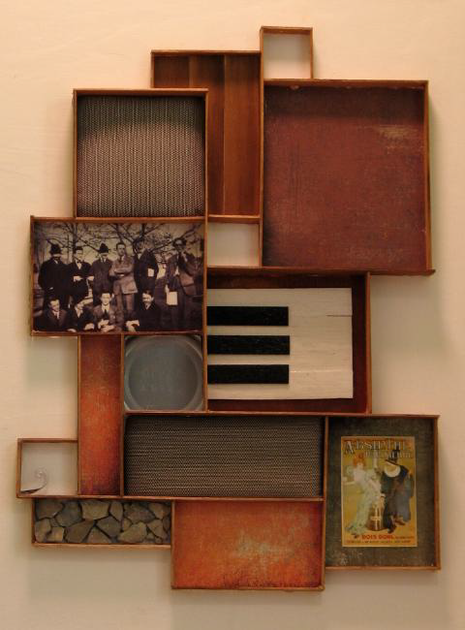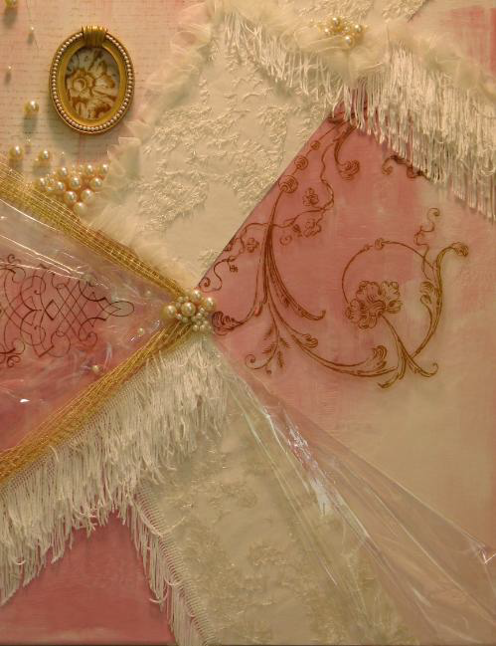

Portrait of the Arensberg Salon Portrait of the Stettheimer Salon
Collages by Erin McCurdy, 2008

Installations and performances by Karen Aagaard, May Chew, Shannon Culver, Emma Doran, Rachel Frohlich, Robyn Harper, Paromita Kar, Daniel Marrone, Erin McCurdy, Richard Rosenbaum, Julian Smith, and Annie Vong.

Sponsored by The Modern Literature and Culture Research Centre and the Office of the Provost and Vice President Academic, Ryerson University.

CONTACT: Paromita Kar (416) 898-7614; paromita.kar@gmail.com
Richard Rosenbaum (647) 230-7177; richard.rosenbaum@ryerson.ca

